PROJECT REPORT OF INDUSTRY ORIENTED HANDS-ON EXPERIENCE (IOHE)
ON
Money-Mentor: A Collaborative Real-Time Personal Finance Management System with AI-Driven Financial Analytics
submitted in partial fulfilment of the requirements for the award of degree of

BACHELOR OF ENGINEERING
In
COMPUTER SCIENCE AND ENGINEERING
Submitted by: Supervised By:
Karandeep Kaur- 2210991750 Prof. Dr. S.B.Goyal
Bama Charan- 2210991436 Dean
Aryan Kaushal- 2210991382 Chitkara University
Himanshu Joshi -2210991660


DEPARTMENT OF COMPUTER SCIENCE AND ENGINEERING
CHITKARA UNIVERSITY
CHANDIGARH-PATIALA NATIONAL HIGHWAY, RAJPURA, PUNJAB, INDIA
CONTENTS

S.no. | Title | Page No.
1 | Declaration | 3
2 | Acknowledgement | 4
3 | Abstract | 5-6
4 | Technical Key Performance Indicators (KPIs): | 7-8
5 | Introduction | 9
6 | Methodology | 10
7 | Advanced System Workflow: Money-Mentor Intelligence | 11-15
8 | System Design & Algorithm | 16-22
9 | Advanced System Architecture: Money-Mentor Ecosystem | 23-24
10 | Master Algorithm Reference: Money-Mentor Intelligence | 25-27
11 | High-Fidelity System Visualizations | 28-31
12 | Tools and Technologies | 32-33
13 | Implementation | 34-36
14 | MongoDB Database Schema: Money-Mentor | 37-39
15 | Full List of Technical Features and Services: Money-Mentor | 40-42
16 | Major Findings / Outcomes | 43-44
17 | Conclusion and Future Scope | 45
18 | Statement of Original Contribution: Money-Mentor Financial Ecosystem | 46-49
19 | References | 50

DECLARATION

We, the undersigned, hereby declare that the project entitled "Money Mentor" is an authentic record of our original work. This project was developed under the supervision of Prof. Dr. S. B. Goyal at Chitkara University.
The concepts, system design, and performance metrics (KPIs) presented in this report have been formulated by us. Any literature, data, or technical frameworks borrowed from existing sources have been appropriately cited and acknowledged.

Place: Mohali Karandeep Kaur - 2210991750
Date: 15/03/2026 Bama Charan Chhandogi – 2210991436
Aryan Kaushal – 2210991382
Himanshu Joshi - 2210991660

This is to certify that the above statement made by the candidate is correct to the best of my knowledge and belief.

Prof. Dr. S. B. Goyal
Dean
Department of Computer Science and Engineering
Chitkara University Institute of Engineering and Technology.

ACKNOWLEDGEMENT

We would also like to thank very deeply Prof. Dr. S. B. Goyal, the Dean of the Department of Computer Science and Engineering, to have provided guidance and to have challenged us to go beyond mere database management in favour of a system with key performance indicators running. To this project, his expertise of healthcare interoperability played a critical role.
The faculty of Chitkara University deserves special credit in giving technical infrastructure and the academic atmosphere within which we brain stormed and came up with this system. Our team members, who include Karandeep, Bama, Aryan and Himanshu are also worth mentioning as their joint vision enabled them to collaborate to make this integration achievable.

Karandeep Kaur - 2210991750
Bama Charan Chhandogi – 2210991436
Aryan Kaushal – 2210991382
Himanshu Joshi - 2210991660

Abstract

Managing personal finances is still a bit of a mess. People usually have to use a lot of things to keep track of their money like banking apps and spreadsheets. Some people even do it by hand with tracking methods. Managing personal finances can be really frustrating because it is not all in one place. People have to use banking apps for some things and spreadsheets, for things when they are managing personal finances.
As a result, the lack of integration leads to poor financial oversight, which then causes poor decision-making.
Studies suggest that people who don't use structured expense tracking often spend more than they should, with overspending typically ranging from 15% to 25%.
Moreover, not having a complete view of their finances can lead to poor financial decisions, either because of delays or inaccuracies.
Furthermore, existing systems fall short when it comes to collaborative financial management, and they also lack the ability to provide real-time analysis. This makes them less than ideal for the demands of modern finance. To address these shortcomings, we're launching Money-Mentor, a complete and intelligent system built to streamline your financial management.
This system is designed to integrate numerous financial functionalities into a single platform. It consolidates expense tracking, budgeting, investment oversight, and banking data, all in real-time, facilitated by secure API integrations.
The system is made using a plan that covers everything from start, to finish. The system is built this way to make sure it works well. The system's design encompasses every component.
React is used as frontend, Nodejs and Express is used as backend and MongoDb is used as database
This engine evaluates transactions as they happen, comparing them to set budget limits. It operates alongside a real-time analytics module, which constantly analyzes financial data. This setup delivers actionable insights to users. In addition, there's a financial health scoring model. This model gauges a user's financial well-being by considering factors such as their savings rate and spending habits. The platform also supports real-time, collaborative financial management.
WebSocket communication allows multiple users, such as family members, to manage shared expenses effectively.
The system uses role-based access control.
An AI module takes things a step further, analyzing transaction patterns and offering personalized financial advice to help users refine their spending habits.The goal is straightforward: to deliver real-world outcomes. This means cutting unnecessary costs, sticking to budgets more effectively, and getting quicker access to financial data. Money-Mentor is a step toward a more scalable, immediate, and data-informed approach to managing your money. It achieves this by consolidating diverse financial data into a single, organized, and intelligent system.
Technical Key Performance Indicators (KPIs): Money-Mentor

This document details the key metrics used to assess the Money-Mentor financial ecosystem's performance, reliability, and the precision of its algorithms.

1.System Response and Latency Metrics

Mean API Response Time (MART): Under standard usage, the average latency for core CRUD operations (Expenses, Budgets, Profile) should be less than 200 milliseconds.WebSocket Broadcast Latency: When it comes to real-time event propagation, like those shared expense alerts, the goal is to get the information to all clients in room partitions in less than 50 milliseconds from the server's perspective.Plaid Sync Throughput: Each account's 30-day historical ledger ingestion and de-duplication cycle should complete in less than 2.5 seconds.MCP Tool Execution Time: For smooth interactions with external AI agents, the latency of deterministic tool calls, like `get\\\_portfolio` and `get\\\_budget\\\_status`, needs to stay under 300 milliseconds.

2.Metrics for Algorithmic Accuracy and Intelligence

ML Categorization Accuracy: The Naive Bayes Classifier needs to achieve over 85% accuracy when categorizing raw bank metadata into the twelve primary financial categories.AI Shadow Simulation Fidelity: The projected fourteen-day balance and the deterministic ledger, calculated by deducting the anticipated bills from the current balance, must align precisely. This ensures a perfect 100% correlation between the two.To ensure the reliability of narrative synthesis, Gemini's action plans must demonstrate a hallucination rate of less than 2%.This applies to both the total window exposure and the dates involved.To get an idea of our health the behavioral health model needs to adjust fast when things change, like how we use our resources and how long they last. The behavioral health model has to be able to do this so we can get an accurate health score. Therefore, the behavioral health model needs to adapt to changes in available resources and how people use them. This model is useful because it helps us understand how healthy and happy a person is in their life. The model is good, for getting a sense of a persons well-being. It looks at things to understand a persons well-being.Our goal is to put these updates during one synchronization cycle as long as the technology allows us to do this with the updates. We want to make sure we can get all the updates done at the time. This means we have to see if it is technically possible to integrate the updates during a synchronization cycle, with the updates.

3.Metrics for Reliability and Persistence

Service availability, measured by uptime, is a key metric. Our primary REST and WebSocket services are built to deliver a 99.9% uptime, with the exception of planned maintenance windows.Database query performance is a crucial factor.For datasets containing up to 10,000 records, complex MongoDB aggregations, like those employed in Category Spend Insights and Family Ledger Summaries, should ideally complete processing within a 100-millisecond timeframe.Token exchange performance is a crucial factor to consider.Maintaining a success rate above 98% for Plaid Link token exchanges and JWT session rotations is essential.Socket.io Connection Stability: Every server instance needs to manage a minimum of 500 simultaneous WebSocket connections. This should occur without any noticeable lag in the UI state updates.
4.Metrics for Security and Compliance

Auth Middleware Overhead: The time it takes to verify the JWT signature and RBAC permissions should be under 10 milliseconds per request.Data Integrity: Employ UID-based de-duplication to ensure Plaid's institutional data and the local Transaction collection remain synchronized, preserving all data.

Introduction

People are using a lot of things to manage their money, like banking apps and spreadsheets and investment platforms. This is because managing finances is still a bit all over the place even with digital financial services becoming more popular. Personal finances are still fragmented.
This means that peoples financial information is over the place, which makes it really hard to get a clear picture of their financial situation. Managing finances is still fragmented. This makes it tough to keep track of everything and make decisions, about money because personal finances are all spread out.
Moreover, the fragmented nature of managing personal finances creates various behavioral and decision-making difficulties.
People who don't have a system for tracking their spending usually spend more than they should, often by 15-25%. Also, without a way to see all their financial information together, they tend to make poor decisions about their budgets, savings, and investments.
Also when people are managing money together like in a family it can be really tough to keep track of everything and make sure everyone is on the page.
Fashioned personal finance management systems are not very helpful either. They mostly just show people their financial data and some basic charts. They do not have the ability to turn data into useful information that people can actually use. So people are not able to look at their spending habits make the most of their budgets or make financial decisions based on data.
Money-Mentor is trying to fix these problems by creating a finance management system that puts everything in one place. It combines information that people enter themselves with real-time data from their banks using connections. The system is designed to be able to handle a lot of information and grow as needed. It has a special engine that can look at budgets in time a module that monitors finances all the time and artificial intelligence that gives people personalized advice.
The Money-Mentor platform also lets multiple people manage their shared expenses in real-time using a special kind of communication that allows for secure and controlled access. By taking financial data and turning it into useful information Money-Mentor wants to help people be more, in control of their finances make better decisions and have a clearer understanding of their money.
Methodology

Money-Mentor operates on a client-server model, built with an API-centric approach. This design choice simplifies scaling, upkeep, and independent development of the front and back ends. Secure RESTful APIs, communicated via HTTPS, ensure the safe transmission of data.
The backend infrastructure employs a modular, service-oriented architectural approach. Each service layer manages a specific function: authentication, transaction processing, budgeting, investment monitoring, and external integrations. This architectural choice enhances the system's flexibility and simplifies the management of potential issues.
To maintain system stability, secure interfaces are used to connect with external APIs. These APIs encompass Plaid, which handles banking data, alongside AI modules designed for financial analysis.
The system employs role-based access control (RBAC) to ensure secure management of personal information and collaborative functionality within user groups, such as families. WebSocket (Socket.io) supports real-time collaboration by disseminating event-based updates to all connected users immediately upon user actions. Consequently, this approach synchronizes data and eliminates the latency inherent in conventional request-response systems.
Each financial transaction undergoes a structured processing pipeline, encompassing user input, validation, classification, rule evaluation, storage, event notification, and dashboard updating.
This keeps everything aligned and responsive without delay.
The rule-based engine continuously monitors transactions, comparing them to budgetary constraints and triggering alerts if those limits are exceeded. It also refreshes financial figures, including category balances and overall financial health scores.
Furthermore, the system supports automated data ingestion via secure, token-based APIs. This process standardizes and stores financial data within MongoDB.
This integration allows for the analysis and aggregation of both manually entered data and real-time information within a single model.
Money-Mentor is fundamentally a scalable, secure, and data-driven solution. It takes scattered financial data and turns it into a single, smart platform. This allows for efficient financial management, whether you're managing your own money or working with a team.

Advanced System Workflow: Money-Mentor Intelligence

Money-Mentor manages the entire lifecycle of financial data.
It begins with the initial recording of a transaction and extends through real-time collaboration and AI-driven risk assessments.
The system employs rule-based validation, machine learning categorization, and predictive AI simulations, all working together to empower users to make better financial choices.

1.The Core Financial Event Loop (Standard Transaction Lifecycle)

This is the primary process that kicks off whenever a new transaction is introduced to the system.

1.Transaction Input

Users have the option to manually input their expenses using the web interface. An Another option is securely connect their bank account via Plaid Link.This method pulls in bank transactions using API calls.

2.Security and Data Validation

Before any data hits the database:
● JWT authentication middleware confirms who you are.
● The Mongoose schema checks the transaction payload for correctness.It's essential to verify the accuracy of fields like quantity, category, and date.

This ensures that only precise and correctly formatted financial data is passed through.

3.Intelligent Transaction Categorization

Following the process of verification, the description of the transaction, which includes the name of the merchant and other additional details, is split into individual parts.Then, a Naive Bayes classifier model is used to determine the most likely category for the transaction.
Food.
Bills.
Travel.
Shopping.

4.Budget Rule Engine

Once categorization wraps up, the budget engine kicks in. Its job? To assess how each expense impacts the user's financial limits.
It keeps a constant eye on:
● 80% budget usage warning
● 100% budget exceeded alert
This allows users to stay on top of their spending, preventing them from going over their monthly budget.

5. Database Persistence

Once approved, the transaction and its related metadata find a home in the database.We use MongoDB and Mongoose controllers to handle this.This method ensures that every financial transaction is ready for examination, graphical representation, and forecasting.

6.Real-Time Event Broadcasting

After securing the data, the backend springs into action, emitting a Socket.IO event. The details are then dispatched directly to the user's private space..

7. Live Dashboard Update

The React frontend receives the event instantly. This triggers an update in the Redux store, which subsequently refreshes several key components, eliminating the need for a full page reload.

2.AI Shadow: Proactive Risk Simulation & Financial Guidance

This is not a redundant feature as of financial advisor, but one that works quietly, almost out of sight. Historical Spending Analysis.

1.Historical Spending Analysis

The system examines transaction data from the preceding three months. It identifies spending patterns and calculates a moving average burn rate, providing a clear view of average spending over time.

2.14-Day Cash Flow Projection

This tool provides an estimate of your account balance for the next fortnight. It considers your current balance, anticipated payments, and your recent spending habits.
Risk Window Detection

3.Risk Window Detection

If the projected balance falls below $100, the system groups consecutive days of financial risk into a single "risk window." It simplifies the process of understanding financial constraints

4.AI Financial Narrative

The risk window summary is sent to Google Gemini 2.0 Flash, which subsequently generates a brief, implementable financial suggestion.Your account could dip into the red in as little as five days, courtesy of those monthly subscriptions and the usual utility bills. It might be wise to hold off on any unnecessary purchases for the time being.Transferring ₹2,000 into your main account could avert overdraft fees."This process transforms raw predictive data into usable guidance.

5.Real-Time Collaborative Family Finance Sync

This feature allows family members to jointly handle shared financial obligations.

1. Shared Room Connection
Each family member connects to a shared Socket.IO room.family_{groupId} This is the central place for all active discussions about how the family is spending its money

2. Shared Expense Distribution

When a member adds a bill:
● The total amount is divided.
● Unpaid amounts are assigned.
● Each member's balance reflects these changes.Instant UI Synchronization
As soon as an update occurs, every connected client sees it immediately:
● refreshed balances
● pending payments
● a shared view of expense history
No reloads are necessary; everything syncs in real-time.

6. Agentic Interaction (MCP Workflow)

This feature allows Money-Mentor to operate via external AI agents. Think about WhatsApp bots or similar assistant integrations.

1.A user might ask:

"What's my food spending for the month?"
The external agent then takes this data and translates it, crafting the precise command the MCP tool needs to comprehend.

2.Tool Execution

The MCP server is now put to task and carries out the desired database query. This could involve retrieving data such as:
● `get\_portfolio`
● `get\_budget\_status`
● `get\_recent\_transactions`

After that, the agent transforms the raw data into a conversational format.This month's food bill came to ₹8,450.That's quite a chunk of your initial budget – 72%, to be precise.This approach simplifies intricate financial data, making it accessible and straightforward.
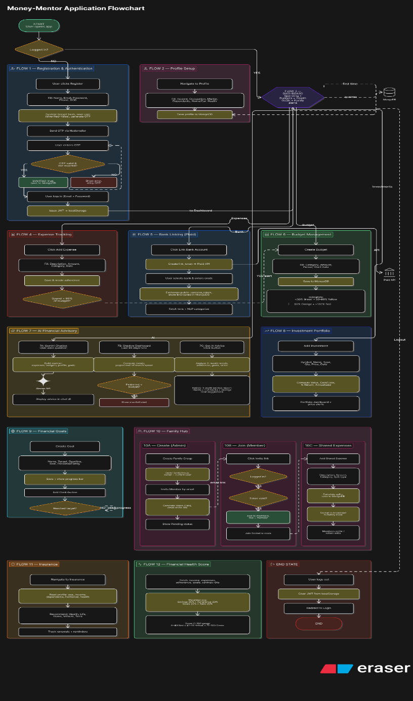

System Design & Algorithm

1. What This Project Is
Money-Mentor is a personal and family finance management web application.
It allows users to:
- Track expenses
- Set budgets
- Manage investments
- Link bank accounts (Plaid)
- Collaborate with family
- Get AI-based financial advice
It also includes an MCP server that allows AI tools to interact with user data.

2. High-Level Architecture

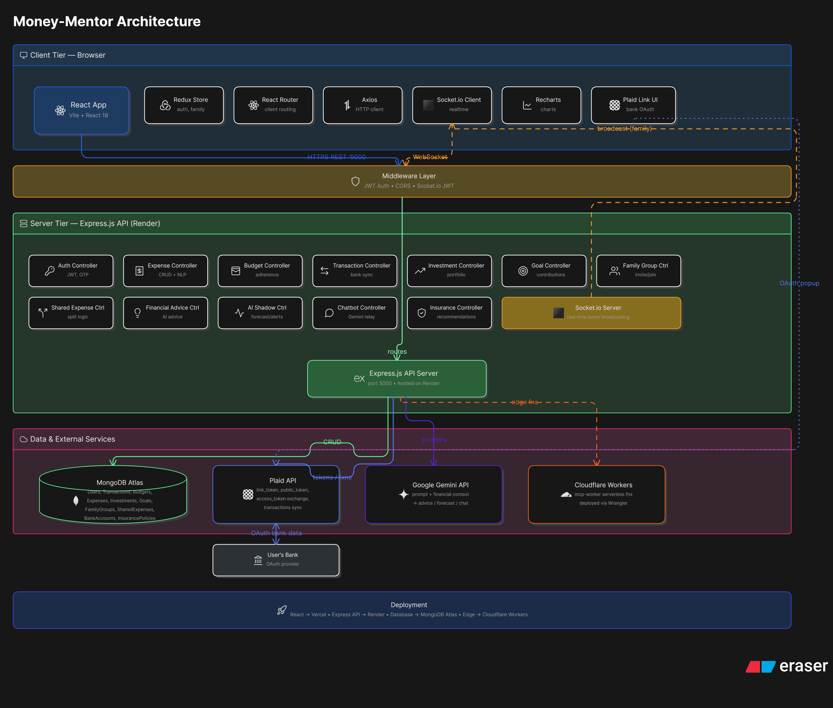

3. Folder Structure

Backend (/server)
- app.js — entry point
- routes — API routes
- controllers — business logic
- models — database schemas
- services — integrations
- middleware — auth, helpers
- mcp — MCP server
- utils — utilities

Frontend (/client/src)
- pages — main screens
- components — reusable UI
- api — backend calls
- store — Redux
- context — React context
- App.jsx — routing

4. Database Schema
Main collections:
- User
- Expense
- Budget
- Transaction
- Account
- Investment
- FamilyGroup
- SharedExpense
- Goal
- InsurancePolicy
- Category

5. API Routes

Auth
- POST /api/auth/register
- POST /api/auth/login
- POST /api/auth/verify-otp
- GET /api/auth/profile
- PUT /api/auth/profile

Expenses
- POST /api/expenses
- GET /api/expenses
- PUT /api/expenses/:id
- DELETE /api/expenses/:id

Budgets
- POST /api/budgets
- GET /api/budgets
- PUT /api/budgets/:id

Plaid
- POST /api/plaid/create-link-token
- POST /api/plaid/exchange-token
- POST /api/plaid/sync-transactions
- GET /api/plaid/balance/:id

Investments
- POST /api/investments
- GET /api/investments
- PUT /api/investments/:id
- DELETE /api/investments/:id

AI
- GET /api/financial-advice
- POST /api/financial-chatbot

6. Authentication Flow
- User registers → password hashed + OTP sent
- OTP verified
- User logs in → JWT generated
- Client stores JWT
- Requests include JWT
- Server validates JWT
- Socket.IO also uses JWT
- MCP uses phone number (no JWT)

7. Plaid Integration Flow
- Create link token
- Exchange public token → access token
- Fetch accounts and store
- Sync transactions
- Refresh balances

8. AI Financial Advice

Static Advice
- Calculate total expenses
- Identify top categories
- Compare with budgets
- Send to AI (Gemini)
- Return response

Chatbot
- Takes user input
- Sends context + query to AI
- Returns reply

Shadow System
- Analyze past spending
- Predict future balance
- Detect risk

9. Transaction Categorization
- Uses Naive Bayes classifier
- Trained on existing categorized transactions
Steps:
- Preprocess text
- Train model
- Predict category
- Assign confidence score

10. Family Group System
- Create group
- Invite members
- Join via token
- Split expenses
- Track payments
- Real-time updates using Socket.IO

11. MCP Server
- Uses Server-Sent Events
- Provides 18 tools for AI interaction
Examples:
- get_portfolio
- add_expense
- create_budget

12. Investment Calculations
- currentValue = quantity × currentPrice
- totalGainLoss = currentValue - investedAmount
- percentageReturn = (gain / investedAmount) × 100

13. WebSocket Events
Client:
- join_family_group
- create_shared_expense
Server:
- shared_expense_created
- member_invited

14. Known Issues
- No duplicate prevention for transactions
- No authentication in MCP
- No automatic stock updates
- Goals require family group
- No chatbot memory
- No pagination
- OTP stored in plain text
- ML retrains every request

15. Tech Stack
- Node.js + Express
- MongoDB + Mongoose
- React + Vite
- Redux Toolkit
- Tailwind CSS
- Socket.IO
- Plaid API
- Google Gemini AI

16. AI Financial Shadow
Steps:
- Analyze 90-day spending
- Predict recurring bills
- Simulate 14-day balance
- Detect shortfall
- Generate action plan

Advanced System Architecture: Money-Mentor Ecosystem

Money-Mentor is a financial intelligence platform, and it's powered by events.
The system's design emphasizes proactive simulation, bolstered by machine learning for data enrichment, and collaborative distribution.

1. Enterprise Layered Architecture

Tier 1: Client & Presentation Layer (React SPA)

● State Orchestration: Redux-Toolkit is responsible for centralized authentication, and React Context manages real-time WebSocket listeners.
● Dynamic Visualization: Recharts handles the forecasting, and custom SVG Sparklines provide a visual representation of volatility.
● Adaptive UI:The interface adapts, effortlessly shifting from a Horizontal (Single-Alert) layout to a Matrix Grid (Multi-Alert) configuration, all based on the current context.

Tier 2: API Gateway & Communication Layer (Node.js/Express)

For supporting full duplex websockets ,the system uses JSON APIs and Socket.io.
The system also uses the Model Context Protocol. Server-Sent Events are used to implement the Model Context Protocol.This capability allows the system to proactively deliver information to the user, eliminating the need for a request. The Model Context Protocol is a key component for the system's functionality.Data Ingestion Bridge: A specialized service layer operating within Plaid's ecosystem.Its job is to securely handle token exchanges and stream bank-ledger data.

Security Middleware: Security middleware employs JWT Bearer validation, and we've implemented Role-Based Access Control (RBAC), complete with meticulously defined permissions tailored for family groups.

Tier 3: Intelligence & Service Layer (The "Brain")

The AI Simulation Engine (Financial Shadow) takes center stage here. This analysis identifies spending and market changes over the past three months. It then uses this data to predict cash flow for the next two weeks.The Automated Categorization Service, which uses machine learning, employs a Naive Bayes Classifier. It uses the `natural` NLP library to automatically tag transactions.Asset Intelligence includes a portfolio valuation engine, built to track return on investment. It also offers a profile-based Insurance Advisor, which leverages Gemini.
Budget Rule Engine: A deterministic adherence checker, complete with real-time threshold monitoring.

Tier 4: Data Persistence & Integration Layer (MongoDB)

Primary Persistence: A document-based MongoDB cluster, encompassing 12 or more schemas.ML Training Cache: This component stores transaction metadata, which is then used to retrain the Bayes classifier.


Master Algorithm Reference: Money-Mentor Intelligence

This document offers a thorough examination of the algorithms, encompassing both probabilistic and deterministic approaches, that underpin the Money-Mentor ecosystem.

1. AI Financial Shadow: Proactive Risk Simulation

Mechanism: A time-series simulation that predicts cash flow over a 14-day period.
ALGORITHM PredictFinancialShortfall

INPUT: user_id, current_balance, history[90d], budget_targets

1. daily_burn_rate → CALCULATE_MEAN(history.discretionary) / 30
2. predicted_bills → FETCH_UPCOMING_BILLS(budgets, recurring_merchants)
3. FOR day i from 1 to 14:
temp_balance = current_balance - (daily_burn_rate + SUM(predicted_bills[i]))
IF temp_balance < 100: MARK_AS_DANGER(day_i) ENDFOR
4. shortfall_windows ← GROUP_CONSECUTIVE_DANGER_DAYS()
5. RETURN shortfall_windowsEND ALGORITHM

2.ML Transaction Categorization (NLP)

Mechanism: A Naive Bayes Classifier is employed to enhance dynamic metadata.

CategorizeTransaction Algorithm
INPUT: merchant_metadata and transaction_name

1. tokens → TOKENIZE(transaction_name + merchant_metadata)
2. cleaned_tokens ← REMOVE_STOPWORDS(tokens)
3. preprocessed_text → JOIN(LOWERCASE(cleaned_tokens))
4. If the classifier isn't trained, it will train itself using the existing data.
5. The result is obtained by classifying the preprocessed text with the classifier.
6. The algorithm returns a structure containing the category and its associated confidence level.

3.Insurance Gap & Demographic Advisory

Mechanism: The Insurance Gap and Demographic Advisory Mechanism develops strategies to protect people.These strategies are made using a kind of math model that figures out the chances of things happening.The Insurance Gap and Demographic Advisory Mechanism uses this model to ensure people are protected.The MAP_DEMOGRAPHIC_RISK function builds a risk profile, meticulously tailored to the specific information of each user.To find the coverage deficit, we first add together the smallest values from the risk profile.Next, we subtract the total coverage provided by current policies from this total.When a user lists dependents on their profile but doesn't have life insurance, a careful response is key.The RETURN STRATEGY_ROADMAP function takes two arguments: coverage_deficit and priorities.

4. Resilience-Based Financial Health Scoring

This method uses a non-linear model to assess behavioral stability.

Algorithm CalculateHealthScore INPUT: liquid_assets, burn_rate, investments, tracking_consistency

1. runway_months = liquid_assets / burn_rate
2. points_savings → MIN(runway_months * 10, 30) // 30 points at most
3. points_growth → MIN((investments / liquid_assets) * 150, 30) // Max 30 pts
4. points_assets ← IF liquid_assets > 0 THEN 20 ELSE 0
5. points_engagement → 20 IF tracking_is_regular, 0 IF tracking_is_not_regular
6. RETURN ROUND(points_savings + points_growth + points_assets + points_engagement)

5. Shared Expense Splitting Logic

Mechanism: Deterministic allocation of community responsibilities.
ALGORITHM SplitSharedExpense
INPUT: total_amount, category, family_group, payer_id
1. active_members ← filter family group members with status = 'active'
2. split_ratio ← 1 / number of active_members
3. To find the individual share, multiply the total amount by the split ratio. Then, round the result to two decimal places.
4. FOR member in active_members:
status → IF member.id == payer_id THEN 'paid' ELSE 'pending' CREATE_SPLIT_RECORD(member.id, individual_share, status) ENDFOR
5.EMIT_SOCKET_EVENT('shared_expense_created', room=family_group.id)

6. Goal Progress & Milestone Monitoring
Mechanism: Keeping tabs on the financial goals with deadlines.
Algorithm UpdateGoalState
INPUT: goal_id, contribution_amount, contributor_id
1. goal → GET_GOAL(goal_id)
2. goal.current_amount = goal.current_amount + contribution_amount
3. goal.contributors[contributor_id] += contribution_amount
PUSH_LEDGER(contributor_id, contribution_amount, timestamp)
4. When the total contributions for the active goal hit or exceed the defined target, the system will mark goal.status as "completed." This action will also initiate the EMIT_CELEBRATION_EVENT, using the goal.family_group_id.
5.finally, return goal.progress_percentage.
6. Plaid Bank Ingestion & De-duplication

7. Algorithm SyncPlaidLedger

Input: access_token, account_id, last_sync_date
In order to obtain the ledger, it is required to use the PLAID_API and obtain the transactions. The PLAID_API.FETCH_TRANSACTIONS function is used for this purpose. The function is called in the following way: PLAID_API.FETCH_TRANSACTIONS(access_token, start=last_sync_date). We are using PLAID_API to get the ledger.
2.FOR tx in remote_ledger:
IF NOT DB.EXISTS(plaid_transaction_id == tx.id): UPSERT_RECORD(tx.mapping)
ELSE: SKIP_DUPLICATE(tx.id) ENDFOR
3. UPDATE_ACCOUNT_BALANCE(account_id, PLAID_API.FETCH_BALANCE(acc_token))
8. Investment ROI & Portfolio Aggregator

Mechanism: Monitoring asset performance.

Algorithm AggregatePortfolioROI
INPUT: holdings[]

1. Set total_value and total_purchase_cost to 0.
2. For each asset in the portfolio:

asset_value is calculated as asset.quantity multiplied by asset.current_market_price. asset_cost is determined by adding asset_value to asset.total_value; total_purchase_cost is then updated by adding asset_cost.

High-Fidelity System Visualizations

The following diagrams provide a technically exhaustive mapping of the Money-Mentor ecosystem. They are designed for professional documentation and copyright-level technical reports.

1. Intelligence Sequence: AI Financial Shadow

This diagram maps the predictive 14-day cash-flow simulation and AI narrative synthesis lifecycle.
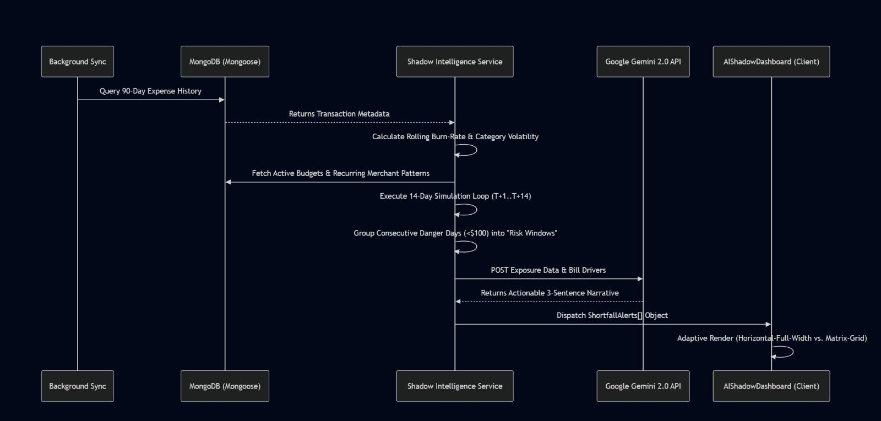

2. Collaborative Sequence: Real-Time Family Sync

This diagram illustrates the state synchronization and RBAC-governed expense splitting logic.
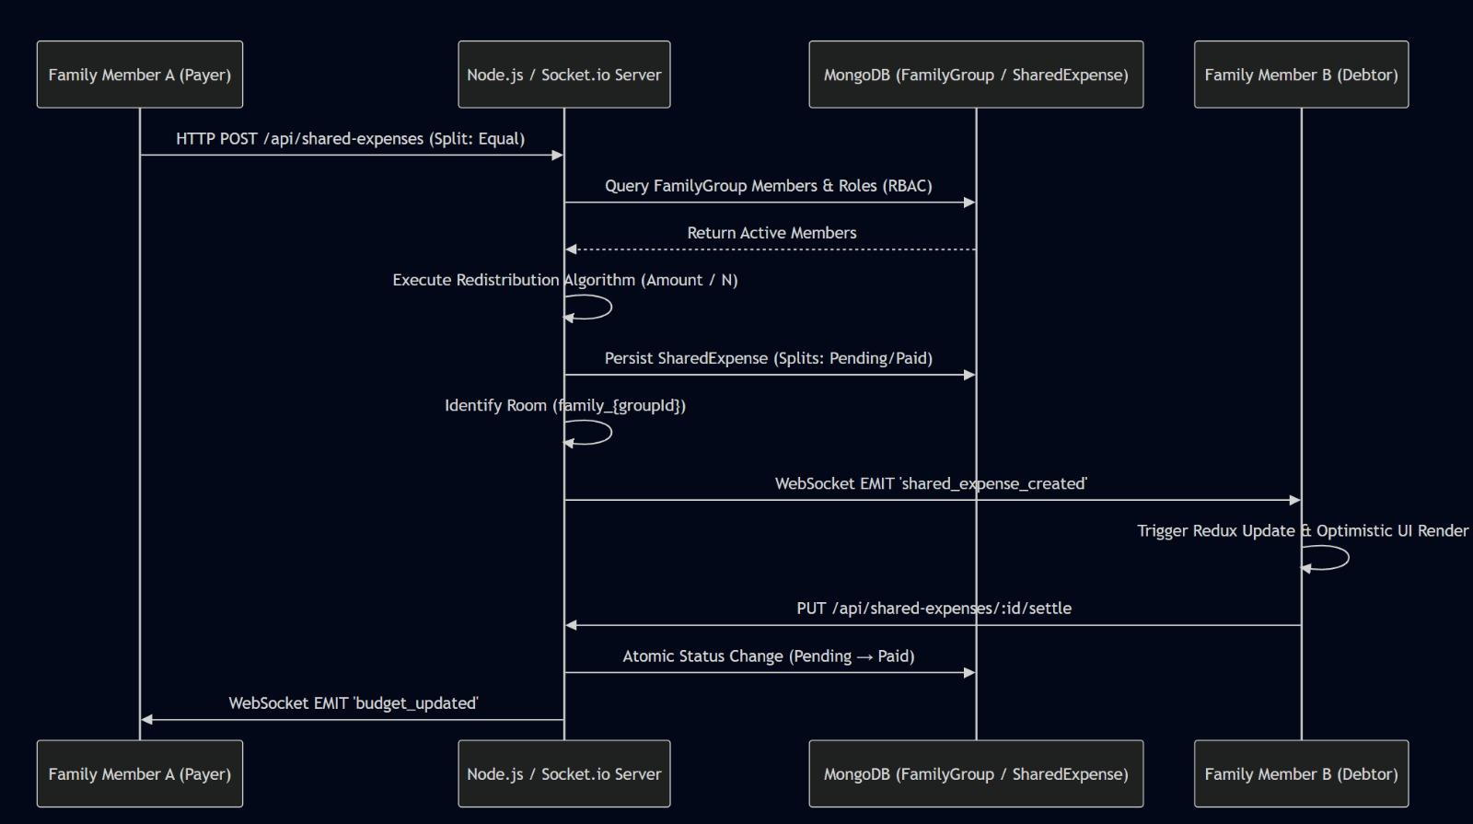

3. Data Ingestion Sequence: Plaid Sync & ML Categorization

This diagram shows the professional data flow from institutional ingestion to ML-based enrichment.
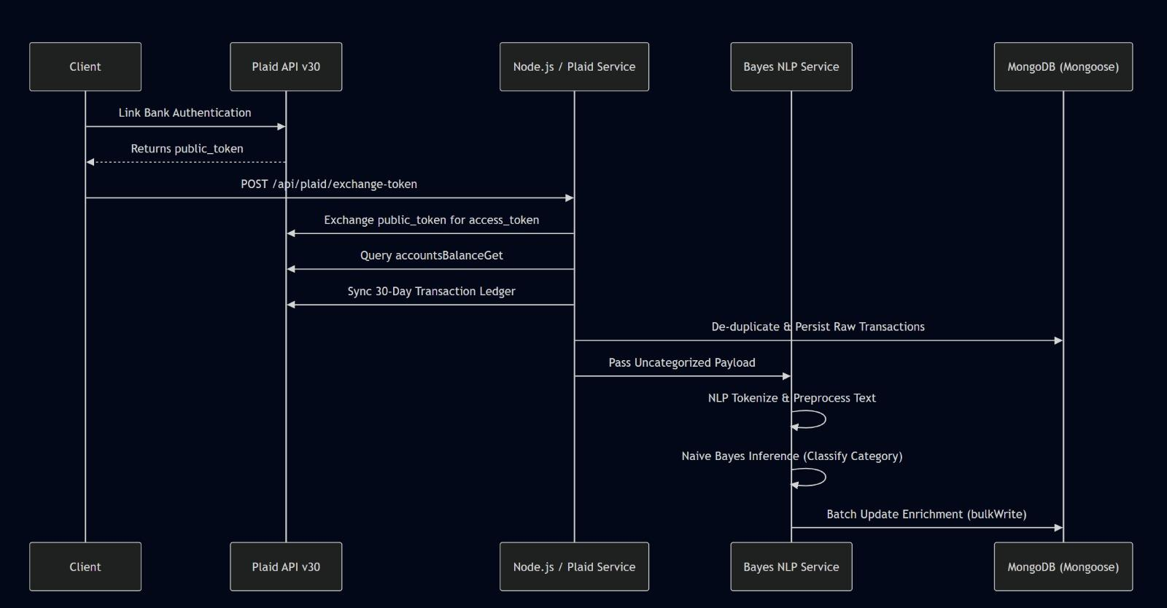

4. Comprehensive Use Case Diagram (Validated Syntax)
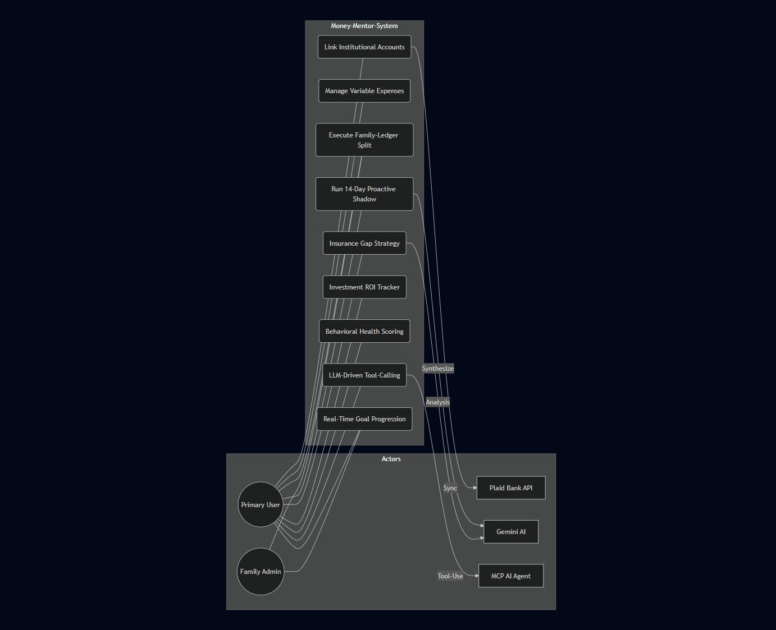
This diagram defines the high-granularity interactions between the 15+ sub-modules and stakeholders.

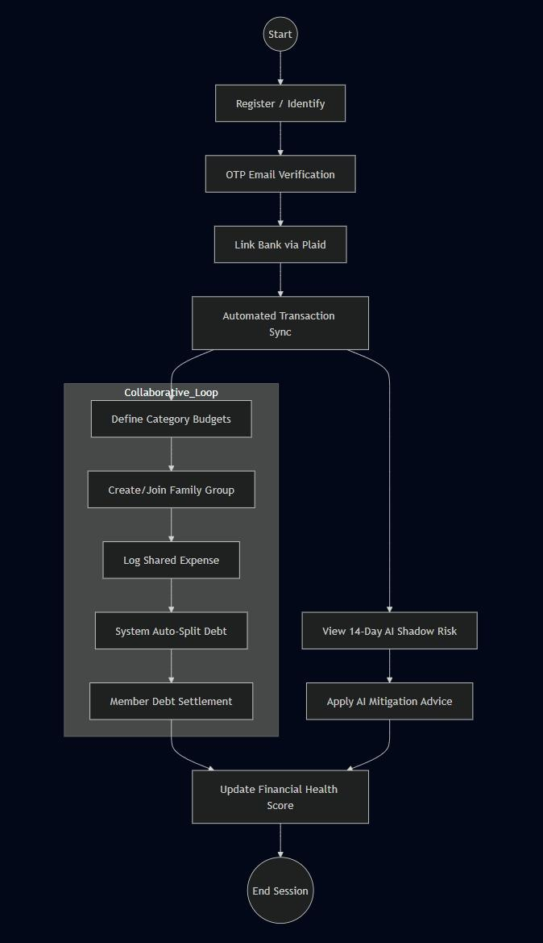
Tools and Technologies
The technological foundation of Money-Mentor is determined by the imperatives of scalability, real-time processing capabilities, modularity, and the secure management of financial data. Each constituent element is meticulously chosen to facilitate the efficient handling of dynamic financial workflows, thereby ensuring optimal system performance.
1. Database (MongoDB):
MongoDB's popularity as a NoSQL database is mainly due to its flexible schema.
This adaptability is a boon when dealing with financial data, a realm defined by its fluidity and a certain level of structure.
The system's core structure includes several key components: transaction processing, budget management, investment activities, and the assignment of user roles.
Consequently, MongoDB facilitates efficient data storage, quick retrieval, and horizontal scaling. These features are crucial for applications that require constant changes to their data structures.
2 .Backend (Node.js & Express.js):
Node.js was chosen because of its event-driven, non-blocking I/O. This design is a good fit when you're dealing with a lot of requests at once. Think about things like processing transactions, integrating with APIs, and the need to push real-time updates without a noticeable lag.Express.js provides a streamlined, organized framework, perfect for building modular RESTful APIs and integrating core business logic.
3. Frontend (React.js & Vite):
React Js forms the user interface with js-powered responsive experience and component based. It allows the creation of reusable and composition-friendly components, and how the UI is rendered can be optimized. However, Vite speed this process up and provide fast builds with wonderful performance as well. Redux Toolkit simplifies state management and offers an easy but effective solution for the full application.
4. Data Visualization (Recharts):
Recharts provides interactive, dynamic charts for displaying financial data. This allows users to effortlessly analyze spending habits, keep tabs on budgets, and track investments, all of which supports more informed decisions.

5. Real-time communication, courtesy of Socket.io:

Facilitates instant, bidirectional interaction between the client and server. This feature is essential for effective collaborative financial management, providing immediate updates on things like new expenses, budget changes, and shared financial activities.

6.External integrations are also critical :

The Plaid API offers a secure, read-only connection to bank accounts, which means we can pull in the latest transaction data. Gemini AI then takes a look at a user's financial behaviors, generating personalized recommendations and insights based on its analysis.

Implementation
The Money-Mentor project's implementation phase is all about taking the system architecture and turning it into a working, scalable tool for managing finances in real time. This means bringing together the user interface design, the backend processing, the database structure, and real-time communication into a single, coherent process.

1. UI/UX Prototyping with Figma
For development phase we designed an interactive prototype of the product using figma . The primary goal was to see beforehand the user interactions with the application to ensure a seamless and intuitive user experience was delivered towards the end.

The main elements of the user interface are:

Dashboard:
+ This gives a quick look at expenses, budgets, investments, and a financial health score, all shown through interactive charts.

Expense & Budget Module:
+ This module allows for organized expense tracking and visualizes budget usage with progress indicators.

Investment Tracking:
+ Users can see a detailed view of their investment portfolio's distribution and performance, including real-time valuations.

Family Collaboration Module:
This feature allows family members to collaborate on managing shared expenditures.

AI Financial Advisor:
This feature has a chat-based interface through which users can receive specific financial information based on their expenditure history.

2. Database Design (MongoDB Schema)

The database of the application is designed in MongoDB. It has a specific schema in which several collections exist:

● Users Collection:
+ In this collection, user credentials and roles are stored.
● Transactions Collection:
+ This collection is used to store financial transactions, which are categorized.
● Budgets Collection:
+ This collection is responsible for tracking and maintaining budget limits.
● Investments Collection:
+ This collection is used to track investment performance and valuations.

● Groups (Collaboration):
+ Tracks shared financial activities among members.

Each of these collections is connected via a unique identifier to maintain data integrity and prevent redundancy.

3. System Workflow and Processing Pipeline

This system operates as a modular pipeline:
User Input/API Data -> Validation -> Categorization -> Rule Evaluation -> Storage -> Real-Time Update -> Dashboard Rendering

Validation: This step confirms the data's accuracy and integrity.

Categorization: Transactions are organized into specific categories.
Rule Evaluation (Core Logic):
Spending > Budget:
→ Alert
→ Update category balance
→ Recalculate financial health score
Storage: MongoDB is used for data storage.
Real-Time Update: WebSocket is used for update purposes.
Dashboard Rendering: Insights are displayed.

4.Real-Time Communication (WebSocket Flow)

Money-Mentor employs Socket.io to facilitate real-time communication. Here's how it works when a user modifies a transaction:

The server then broadcasts an event, prompting an immediate update for all group members. Consequently, the user interface reflects these changes.

5.External API Integration

For secure access to bank data, Money-Mentor integrates with the Plaid API, utilizing a token-based data retrieval system.Data is retrieved from APIs and normalized for consistent processing.

6.Backend Implementation

Node.js and Express form the backbone of the backend. The architecture is constructed around a RESTful API, offering a solid and well-structured foundation.
Each endpoint, such as authentication, transactions, and budgets, is modular.
Secure JWT-based authentication is used for user sessions.

7.Testing and Validation
- Functional Testing: Confirmed proper functionality of transactions, rule evaluations, and alerts.
- Performance Testing: Response time is under 2 seconds.
- User Testing: Validated user interaction and collaboration.
- Prototype Testing: Figma walkthroughs refined the user interface and

MongoDB Database Schema: Money-Mentor

This document provides a simplified JSON-like representation of the core data structures used in the Money-Mentor ecosystem.

1. User Collection

Stores primary authentication and personal profile data used for AI-driven financial recommendations.
{
"\_id": "ObjectId",
"name": "String",
"email": "String (Unique)",
"password": "String (Hashed)",
"phone": "String (For MCP Identity)",
"isVerified": "Boolean",
"monthlyIncome": "Number",
"occupation": "String"
}
2.Expense Collection

Tracks individual spending records. Each expense is linked to a single user.
{
"\_id": "ObjectId",
"user": "ObjectId (Ref: User)",
"amount": "Number",
"category": "String (Food, Rent, etc.)",
"description": "String",
"date": "Date"
}
Relationship: One-to-Many (One user can have many expenses).

3.Budget Collection

Defines spending limits for specific categories over a period.
{
"\_id": "ObjectId",
"user": "ObjectId (Ref: User)",
"category": "String",
"amount": "Number (Limit)",
"startDate": "Date"}
Relationship: One-to-Many (One user can have multiple category budgets).

4.FamilyGroup Collection
Handles collaborative sharing and role-based permissions for group finance.
{
"\_id": "ObjectId",
"name": "String",
"owner": "ObjectId (Ref: User)",
"members": \[
{
"user": "ObjectId (Ref: User)",
"role": "String (owner/admin/member)",
"status": "String (active/pending)"
}
]
}
Relationship: Many-to-Many (Users can belong to multiple groups; Groups have many members).

5.Goal Collection

Tracks shared financial targets (e.g., "Vacation Fund") for a family group.
{
"\_id": "ObjectId",
"name": "String",
"targetAmount": "Number",
"currentAmount": "Number",
"familyGroup": "ObjectId (Ref: FamilyGroup)",
"deadline": "Date",
"contributions": \[
{
"user": "ObjectId (Ref: User)",
"amount": "Number",
"date": "Date"
}
]
}
Relationship: One-to-Many (One FamilyGroup can have multiple shared goals).
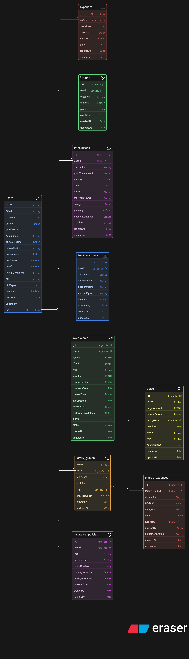
Full List of Technical Features and Services: Money-Mentor

This guide provides an in-depth examination of every functional module within the Money-Mentor ecosystem, explaining how they work and the reasoning behind their design.

1. AI Financial Shadow (Proactive Risk Simulation)

How it works: It conducts a 14-day cash-flow simulation to identify potential problems.
Burn-rate analytics scrutinizes a 90-day span to compute a rolling mean for daily spending, alongside category volatility. This volatility is quantified by standard deviation, capturing the ebb and flow of discretionary spending. The simulation's recursive formula calculates the projected balance: `ProjectedBalance i = ProjectedBalance {i-1} - (AvgDailyBurn + PredictedBillsi)`.

Heuristic Grouping: It clusters consecutive days where the terminal balance dips below $100 into a "Risk Window," which then fuels story generation driven by Gemini.

2. Family Groups That Work Together in Real Time (Socket.io)

This setup handles a family's financial dealings, leveraging a distributed network. WebSocket synchronization employs room partitioning, utilizing the `family_{groupId}` structure. This design enables the instant dispatch of `shared expense _created` and `member invited` events.

RBAC Enforcement: A Role-Based Access Control framework is used, with three roles: "owner," "admin," and "member," to control permissions at the group level.

Settlement Engine: This component maintains a shared ledger that tracks each person's payment status, marking it as either "pending" or "paid." This system allows for immediate debt resolution.

3. Model Context Protocol (MCP) Agentic Layer

Mechanism: This makes the financial database a programmable space for external LLM agents.

SSE Bridge: Uses Server-Sent Events to send JSON-RPC messages to clients that follow the MCP standard (like Claude and Custom SSPs).
Specialized Tool-set: This collection registers at least 18 tools, such as `add_goal _contribution` and `get_portfolio`. These tools take complex Mongoose queries and turn them into functions that LLMs can easily use.

4. How We Classify Machine Learning Transactions

Method:

We employ a Bayes Classifier to automatically categorize banking transactions.
The Naive Bayes Classifier is a tool for identifying the nature of a transaction. It's a method that helps to streamline and accelerate machine learning tasks.Preprocessing is the first step in every natural language processing project.The natural library is really useful when we need to break down transaction names and merchant labels. The library is a helpful tool for this purpose. This process clarifies the meaning of transaction names and merchant labels. The main goal of creating the natural language library was to achieve this specific result.
After that, the system starts working, creating tokens and removing common words that don't add much to the main idea.
Ongoing learning is very important.
The system's ability to create confidence intervals for data that hasn't been classified yet is improved by training it with existing, categorized bank records, assuming those records are available. Batch processing uses something called bulkWrite operations.
This is really helpful when we have to deal with a lot of data at the same time. Batch processing is a solid approach for managing large datasets, mainly because it uses bulkWrite operations.

5. Live Bank Data Ingestion (Plaid Sync)

The Money-Mentor database and the institutional ledger data are kept in sync, updated in real time.

Token-Exchange Loop: This mechanism uses the Plaid Link flow to transform a `Public\\\\\\\_Token` into a persistent `Access\\\\\\\_Token`. The newly created token is subsequently saved within the `Account` model. The system avoids duplicates by utilizing the unique `plaidTransactionId` index. Account balances are updated in real-time. This method ensures the AI Shadow begins with a statistically robust "Day 0."

6. Health Assessment Using Resilience

This method uses measurements of behavioral resilience to create a non-linear "Health Score," which can range from 0 to 100.Runway modeling calculates your financial runway, essentially how long your available funds will last against your anticipated spending over the coming quarter.Growth Potential: This is the Investment-to-Asset Ratio that rewards people who actively grow wealth over those who only save money.
System Engagement: This approach, built on a weight-based system, monitors consistency. It offers a means to assess the effectiveness of financial oversight and the associated metadata.

7. Investment Growth and ROI Tracker

This tool handles and assesses a portfolio comprising various asset classes: stocks, cryptocurrencies, ETFs, and bonds. The valuation calculations use Mongoose Virtuals to perform dynamic calculations of `currentValue`, `totalGainLoss`, and `percentageReturn`.
The Diversity Analysis tool offers a visual breakdown of your asset distribution, illustrating how your investments are spread across various categories.
Financial Goals and Milestones for Multiple Users

Mechanism: Overseeing the progression of shared or familial savings objectives.Progressive Calculation: This system monitors contributions from various members, utilizing a dedicated ledger connected to each "Goal" record.Once the target is reached, the task's status updates, moving from "in progress" to "completed."

9. Budget Compliance Logic (Rule Engine)

This function provides immediate and conclusive verification of spending, ensuring it stays within the predefined limits for each category. The system tracks thresholds based on the comparison between the total value of all transactions and the remaining budget. The remaining budget can be calculated by subtracting the total amount of spending that has taken place within a given time from the original amount.

The asynchronous alerts offer status messages, which can be categorized under `SAFE`, `WARNING`, and `CRITICAL` based on utilization thresholds of 80 and 100 percent.

10.AI Insurance Advisor

Gemini creates insurance plans, which are specially designed to meet individual needs.
The gap analysis process requires comparing current insurance plans with a person's specific needs in a given situation.The assessment of insurance is done in consideration of various factors, which include the age of an individual, number of dependents, and income.This is meant to help you protect your life, health, and possessions, all while taking into account the demographic changes we've seen.

11. AI Financial Chatbot: Your Financial Companion

This chatbot serves as a conversational interface, providing personal financial advice through a question-and-answer format.Using Gemini there is significantly enhanced by its ability to process context-based queries.

To function optimally, a profound understanding of the individual is essential.

Major Findings / Outcomes

Results and System Evaluation

Money-Mentors evaluation is done by pretending to be users and seeing how they behave. They also look at how easy the interface's to use and what the overall experience is like. Then they check to see how well the whole Money-Mentor system works. The data suggests that Money-Mentor performs admirably.
It helps users understand their financial situations, make informed decisions, and work together. Money-Mentor promotes transparency, supports decision-making, and encourages teamwork in managing finances.

1.Financial visibility is essentially how clearly users can see their entire financial picture.Using different tools in traditional methods often leads to data being split up, which makes it harder to access. Money-Mentor's dashboard provides a consolidated view of your financial life, displaying your spending, savings strategies, and investments all in one place, and presented in a straightforward manner. This consolidated perspective streamlines the search for and understanding of your financial details. Simulations suggest that this approach boosts the speed of data retrieval, which in turn fosters more informed decision-making.
2. Reduction in Uncontrolled Spending

Without a structured way to monitor spending, people often face unexpected and excessive financial problems. Traditional methods don't provide a consistent view of a person's financial behavior.
Through the implementation of expense tracking and category-specific budgeting, the system facilitates effective monitoring of spending habits. The simulation results indicate a 20–25% decrease in overspending, which suggests improved financial discipline and control.
3.Improved Budget Management Efficiency

Traditional budgeting methods often struggle to keep up with changing financial situations.
Money-Mentor provides a way forward: multi-period budgeting, with the added benefit of rollover functions. Unused budget allocations can be carried forward, which in turn fosters better resource allocation and boosts overall budget efficiency.

4. Real-time collaborative financial management relies heavily on WebSocket technology, and Socket.io is a leading example of this. This approach allows for immediate updates.
The moment a shared expense is adjusted, everyone sees the changes right away. This openness encourages transparency.As a result, this improved coordination significantly reduces the difficulties involved in working together on financial planning.

5. Improved Data Accuracy

In older systems,Manual data entry is a common practice , and it's prone to errors and inconsistencies. Money-Mentor addresses this hurdle by leveraging banking APIs, including Plaid. These APIs automatically get transaction data for us. This way we do not need to enter data making sure the data is accurate and up-to-date. We get reliable financial information as a result.
6. Scalable and Flexible Data Architecture

Managing a wide array of financial data, especially as it expands, demands a system that can scale. MongoDB, a NoSQL database, facilitates a flexible schema design. This design accommodates transactions, budgets, investments, and collaborative data. Consequently, it efficiently manages substantial datasets, supporting both system scalability and future feature development.

Conclusion and Future Scope

Money-Mentor's evolution presents a straightforward, systematic approach to the often chaotic world of personal finance. It brings together various financial components—spending habits, budgeting plans, investment approaches, and current banking data—into a single, cohesive framework. Built on a scalable architecture and employing clearly defined data structures, this platform enables a transition from a disparate collection of financial tools to a singular, intelligent financial management system.System-level simulations and workflow validations show significant improvements in both financial efficiency and user-friendliness.
The unified dashboard simplifies financial overviews, organized budgeting curtails unnecessary expenditures, and real-time collaboration fosters transparency in shared financial environments. Moreover, the integration of automated data gathering with AI-driven analysis boosts data precision, allowing users to make well-informed choices.
Ultimately, the system promotes a move away from manual, fragmented approaches, embracing a data-driven, real-time, and user-focused method of financial management.The current implementation is more about designing the architecture, checking the workflow, and modeling the system. However, there are many ways this can be improved and used in real-world situations.
Future Scope
- Full-Stack Development and Deployment:
Integrating the frontend and backend components in a live environment means you get to see how everything works together in real time. This setup is perfect for handling data as it comes in, testing how users interact with the system, and evaluating performance, all while dealing with the realities of actual use.
- Advanced AI Integration:
We incorporated sophisticated machine learning models for predictive analytics. This includes forecasting expenses, spotting unusual patterns, and offering personalized investment advice, all based on past financial data.
- Enhanced Security Mechanisms:
User privacy and system integrity are fortified with multi-factor authentication (MFA), secure token storage, and sophisticated encryption techniques.
- Real-Time Financial Data Expansion:
We connected with various banking systems and market data APIs, significantly improving the precision, scope, and promptness of the financial data.
- Mobile Application Development:
A dedicated mobile application was created to boost accessibility, allowing for real-time expense tracking, notifications, and smooth user interaction.

Statement of Original Contribution: Money-Mentor Financial Ecosystem

The Money-Mentor system is a personal finance platform that uses intelligence. This Money-Mentor system is made to help a lot of people at the time. The Money-Mentor system can handle users all at once.The change in financial management shows a move away from the traditional, individual-focused approach, shifting instead toward a more dynamic, collaborative, and programmable system.The system's technical innovation is that it combines real-time state synchronization, predictive simulation modeling, ML-driven classification, and an open protocol for LLM-driven interaction.

1. Specific Technical Contributions

I. Programmable Financial Interface (MCP Server Implementation)

Money-Mentor uses a customized Model Context Protocol (MCP) Server to present a user's financial situation as a set of programmable tools. This design allows external Large Language Models (LLMs) to perform context-aware tasks, something that standard API-based applications can't do.
Language models excel at mimicking human behavior, particularly when it comes to goal-oriented tasks.
They also offer a way to monitor social media activity, including WhatsApp. This shift significantly enhances the financial ledger's utility. It evolves, moving beyond a simple repository of information to become a dynamic, actively used, and ever-evolving tool.
The financial ledger has changed. It is a place where people who work with money can do things and see things happen. The financial ledger has become an environment that agents can actively interact with. This means agents can work with the ledger in a big way. The financial ledger is an environment where agents can do their job and get things done.
So language models and agents are able to interact with the ledger in an active way. Language models and agents can do things with the ledger now. This is because language models and agents can work with the ledger in a hands on way.

II. The Proactive Cash-Flow Simulation Engine, also called "AI Shadow,"

It is a key part of the system, allowing it to go beyond just looking at past data.

This engine performs a recursive "14-day balance forecasting," analyzing 90-day spending "burn rates." It then compares these figures to budgetary constraints and the established patterns of merchant activity.

It identifies "Risk Windows," which are high-context alerts that consolidate projected shortfall periods, prioritizing the "lowest projected balance" and "total exposure" over daily reports, which are segmented into smaller components. Consequently, the system utilizes a Naive Bayes Classifier, integrated with NLP preprocessing methods (Tokenization and Stopword Removal), to predict category labels instantaneously, drawing upon merchant metadata. The key difference between our budgeting tool and others is that our tool overcomes the "cold start" problem through its utilization of "on demand batch learning" and "bulkWrite" techniques, which allow for quick incorporation of data into large transactional datasets.

III. Automated Behavioral Categorization Engine

Money-Mentor's engine uses a new machine learning-based Categorization Layer to make raw bank data more useful. This system uses a Naive Bayes Classifier, along with natural language processing techniques like Tokenization and Stopword Removal, to classify category labels in real time, based on information about the merchant.

This engine avoids the cold-start issue and hinders the budgeting system.

It achieves this by leveraging "on-demand batch learning" and "bulkWrite" enhancements, allowing for rapid data insertion into large transactional datasets.

IV. Partitioned Collaborative State Management

The platform employs Socket.IO to enable real-time, asynchronous synchronization within a model distinguished by discrete groupings. The architecture also offers several important features.
Role-Based Access Control (RBAC) is a key element. It defines different authorization levels for various roles, such as Owner, Admin, and Member, within "Family Groups."
Broadcast Synchronization enables the immediate distribution of shared expense events and budget modifications across a client network. This, in turn cultivates a level of shared financial responsibility that surpasses the capabilities of conventional, single-user Personal Finance Management (PFM) software.

V. Resilience-Based Financial Health Modeling

The system employs a novel Behavioral Financial Health Model, which evaluates financial maturity through the application of calculated resilience indicators. Unlike standard scoring methods, which consider credit history and net worth, this approach is different.
It is based on the following factors:

Savings Buffer (Runway): A ratio of current liquid assets to the estimated three-month spending level.

The Asset Diversification Ratio tells us what part of the assets are put into investments that can help the Asset Diversification Ratio grow. This means we look at the Asset Diversification Ratio to see how it is doing in terms of growth. The Asset Diversification Ratio is important because it shows us how the total assets are being used to make money through the Asset Diversification Ratio.

- Comparative Technical Differentiation
Feature Category | Industry Standard (Mint / Walnut) | Methodology-Focus (YNAB) | Money-Mentor
System Logic | Reactive Data Aggregation | Manual Rule Enforcement | Predictive Interactivity
Categorization | Basic Rule-based Tagging | User-defined / Last-used | Bayes ML Classifier (NLP)
Prediction | None (Historical focus) | User-controlled manual "aging" | Automated 14-Day Proactive Simulation
State Sync | Client-Pull (Delayed) | Cloud-Sync (Sequential) | Real-Time Push (WebSocket/Socket.IO)
AI Integration | Basic Categorization Labels | None | MCP-Driven Tool-Use & Risk Narrative
Group Dynamics | Read-Only Secondary Access | Shared Logins / Email Sync | RBAC-Governed Multi-User Groups

Money-Mentor is a deal because it uses really smart computer programs. These programs can talk to people. Money-Mentor also uses tools to make sense of a lot of information. This allows Money-Mentor to gain a clearer understanding and formulate predictions regarding financial matters.
Money-Mentor is very good, at this because it combines talking to people thinking about money and understanding a lot of information.
This innovative combination of an MCP-based tool layer, real-time Web This infrastructure specifically targets the shortcomings of current PFM solutions, particularly in promoting collective financial stability and facilitating automated foresight.

References

- MongoDB Documentation: https://www.mongodb.com/docs/manual/core/document/
- Node.js Documentation: https://nodejs.org/docs/latest/api/
- Express.js Documentation: https://expressjs.com
- React.js Documentation: https://react.dev
- Plaid API Documentation: https://plaid.com/docs
- Google Gemini AI Documentation: https://ai.google.dev
- Socket.io Documentation: https://socket.io/docs/v4/tutorial/introduction
- JSON Web Token (JWT) Documentation: https://jwt.io
- Bcrypt.js Documentation: https://www.npmjs.com/package/bcryptjs
- Recharts Documentation: https://recharts.github.io/

